Problem 7 (e) simulate and plot the process for positive and negative values of δ (maybe δ = 2 and δ = -2)

Option 1: δ = 2

set.seed(154)

w = rnorm(200); x = cumsum(w)

wd = w + 2; xd = cumsum(wd)

plot.ts(xd, ylim=c(-5,55), main = "random walk (with delta=2)", ylab='')

lines(x, col= 4); abline(h=0, col=4, lty=2); abline(a=0, b=2, lty=2)

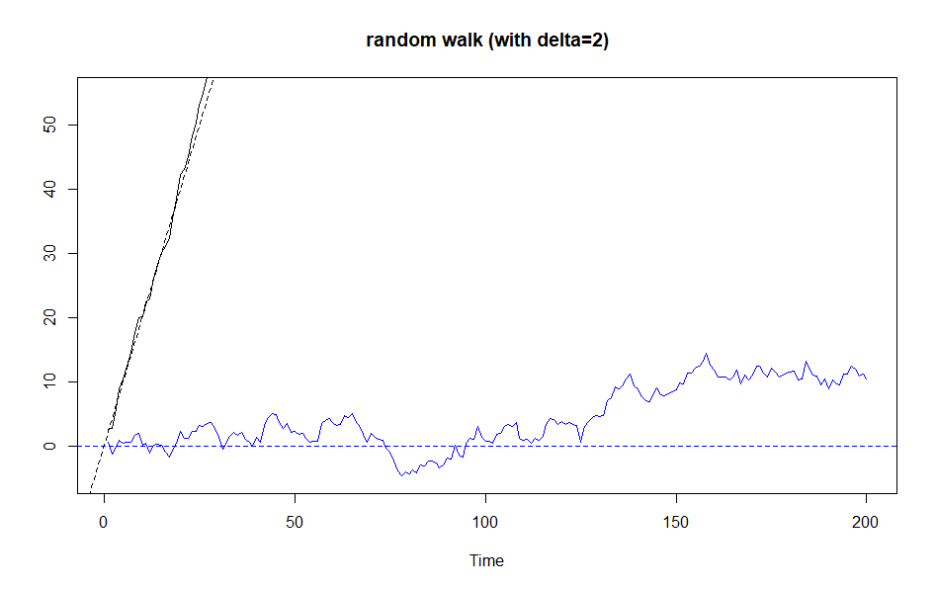

Problem 7 (e) simulate and plot the process for positive and negative values of δ (maybe δ = 2 and δ = -2)

Option 2: δ = -2

set.seed(154)

w = rnorm(200); x = cumsum(w)

wd = w + -2; xd = cumsum(wd)

plot.ts(xd, ylim=c(-5,55), main = "random walk (with delta=-2)", ylab='')

lines(x, col= 4); abline(h=0, col=4, lty=2); abline(a=0, b=-2, lty=2)

